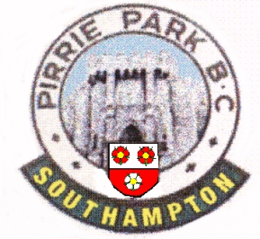
Pirrie Park Bowling Club
78a Wilton Crescent, Upper Shirley, Southampton. SO15 7QE
T Tel: 023 8077 4733 Email: pirriepark2@gmail.com
www.pirriepark.weebly.com

MEMBERSHIP APPLICATION FORM

Membership request
Mr* | Mrs* | Miss* |  | Other*
Name
Date of birth
Membership level |  |  | Full / Sporting/Junior*
*=Delete as applicable

Personal Details
Address line 1
Address Line 2
Postcode
Telephone number
Mobile number
Email address
Next of Kin contact | URGENT

Have you previously been a member of another Bowling Club? YES/NO
If YES, which (1) and for how long? Years
(2) and for how long? Years

If elected, I hereby agree to conform to all rules and bye-laws of the club.
Member
Name (caps)
Signature
Date
_________________________________________________________________________________

I, the proposer has known the applicant for years

PROPOSER |  | SECONDER
Name (caps) |  | Name (caps)
Signature |  | Signature
Date |  | Date
We are of the opinion that he/she is a fit and proper person to become a member of the Club.

***FOR OFFICIAL CLUB USE ONLY***

Date | Membership Number | Card Issued

